Machine Learning

Assignment – 1

Team Members

Divya Mereddy

Kranthi Rekha Rudraraju

Sachin Antony

Snigdha Bhasker Singireddy

Output plots:

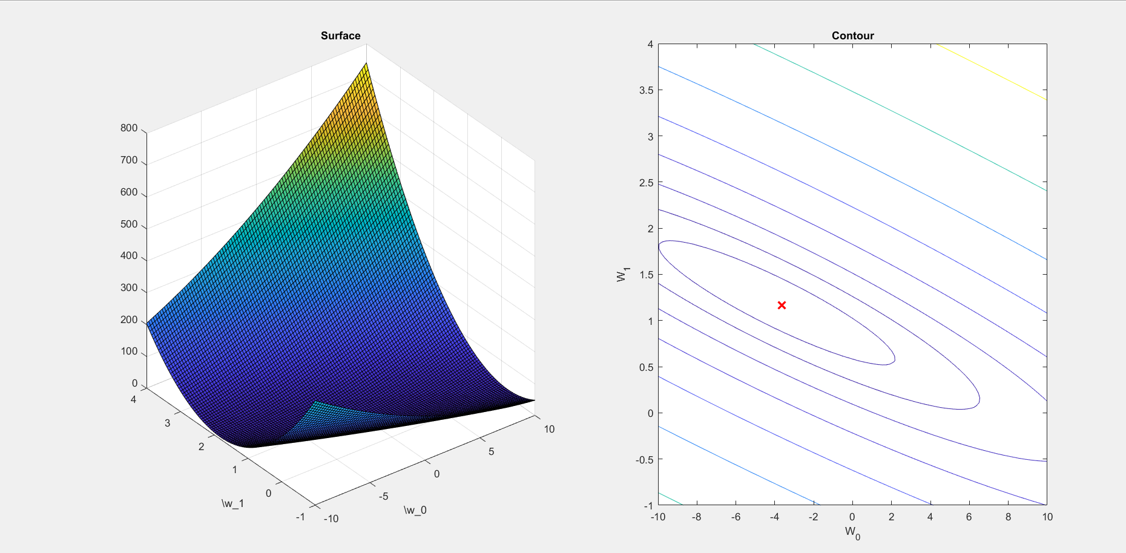

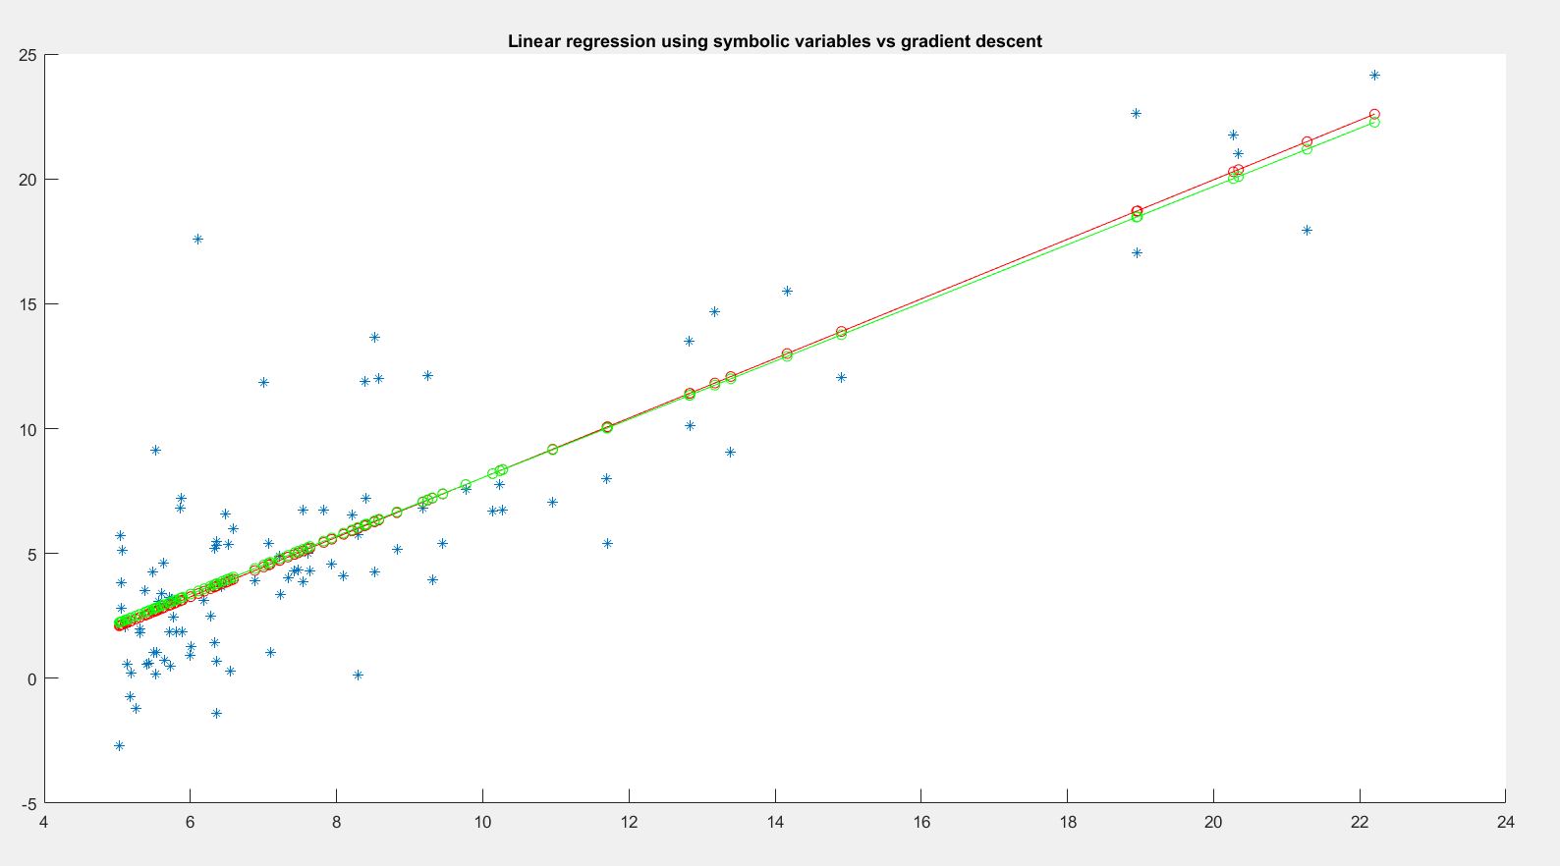

Console Output:

Plotting Data ...

ans =

1 2

ans =

2 1

w0 =

-2716459795461386387/697282491062100000

w1 =

1715219528539/1437695857860

Running Gradient Descent ...

W found by gradient descent: -3.630291 1.166362

For population = 35,000, we predict a profit of 4519.767868

For population = 70,000, we predict a profit of 45342.450129

Visualizing J(w_0, w_1) ...